Attendance Recovery
1.Problem:
Calculate current attendance %and minimum consecutive classes required to reach eligibility threshold.
2.Objectives:
Find current% find how many classes needed to reach 75%.
3.Assumptions.
Total classes conducted attended to known. Need the attendance 75% to be the eligible.
4.Algorithm:
Start
Attended
Per attended_100/total
If per>=75 eligible
Else loop x from 1 until_100/(total+x)>=75
Print(x)
End
5.Pseudo code:
Read
Attended per=attended_100/total
If per>=75
Print(eligible)
Else x=0
While (attended + x)-100/total+x)<75x++
Print(x)
6.Test cases:
1.t1 | Total 100 | Attended 80 | 80%eligible
2.t2 | Total 100 | Attended 60 | Need 60 classes
7.flow chart:
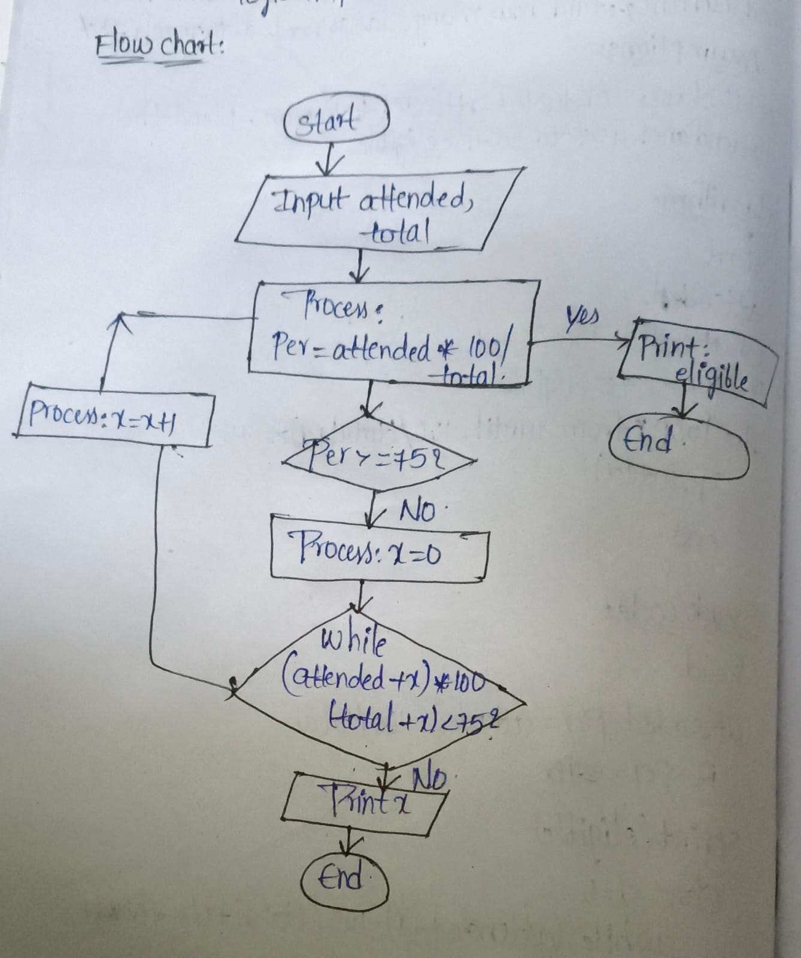
8.code:

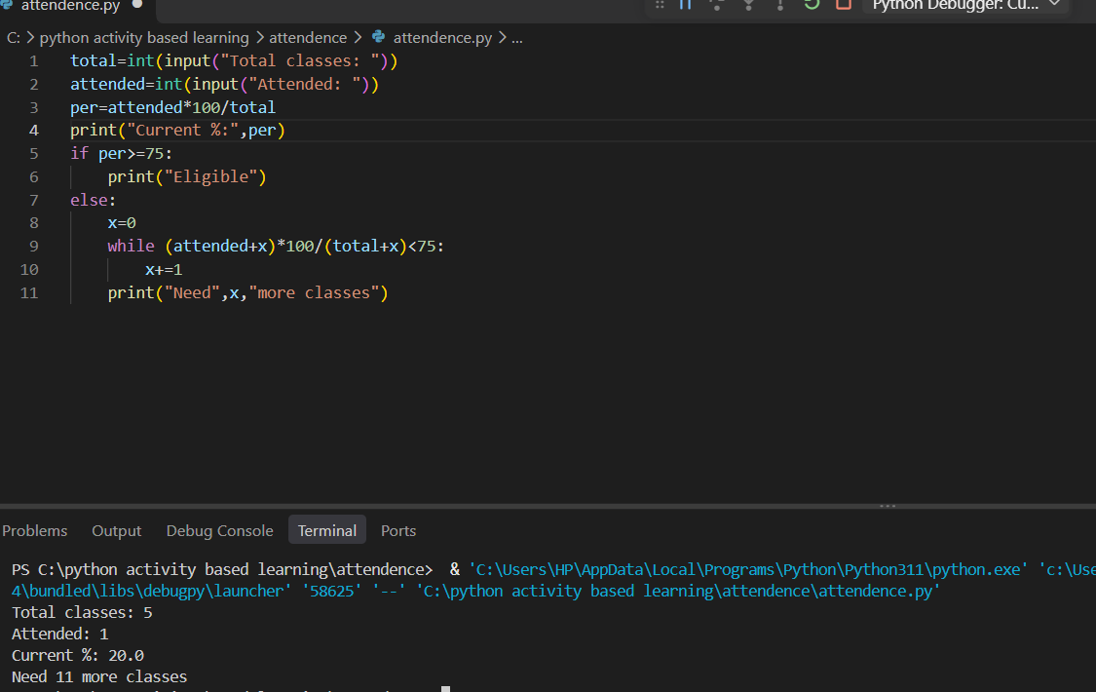
9.conclusion:
All test cases are passed and attendance logic also implemented.

